

|  |  |  |
| --- | --- | --- |
| |  | | --- | | *transform into digital experience* | | **E**xperience + **A**gility + **R**eliability + **T**ime-to-market + **H**ybrid-Cloud | |
| <Hubspot User Guide>  17-Feb-22 |
|  |

|  |  |  |
| --- | --- | --- |
| 「hkt logo」的圖片搜尋結果 |  | http://intra.pccw.com/admin/upload_file/dept/logo31.png |

1 LOGIN HUBSPOT 3

2 UPLOAD ASSET 4

3 TO GET ASSET URL 4

4 TO REPLACE EXISTING ASSET 5

5 TO DOWNLOAD ASSET 6

**Document Control**

|  |  |  |  |
| --- | --- | --- | --- |
| Date | Version | Updated by | Remarks |
| 17 Feb, 2022 | V0.1 | Kwek Yong Hui | Draft version for internal review |
| 14 July, 2023 | V0.2 | Dean Fong | Replace Image |
| 21 Aug, 2023 | V1 | Dean Fong | Added download asset |
|  |  |  |  |

**Reviewers List**

|  |  |  |
| --- | --- | --- |
| Organization Unit | Position Title | Name |
|  |  |  |
|  |  |  |
|  |  |  |

**Distribution List**

|  |  |  |
| --- | --- | --- |
| Organization Unit | Position Title | Name |
|  |  |  |
|  |  |  |
|  |  |  |

**Table of Contents**

1 LOGIN HUBSPOT 3

2 UPLOAD ASSET 3

3 TO GET ASSET URL 3

4 TO REPLACE EXISTING ASSET 3

5 TO DOWNLOAD ASSET 3

# LOGIN HUBSPOT

1. After the user id has been created, go to the UAT Coupon folder URL: <https://app.hubspot.com/files/20288913/?folderId=65935740681>
2. Login Hubspot with email address



# UPLOAD ASSET

1. Drag and drop files from your local PC or click upload files

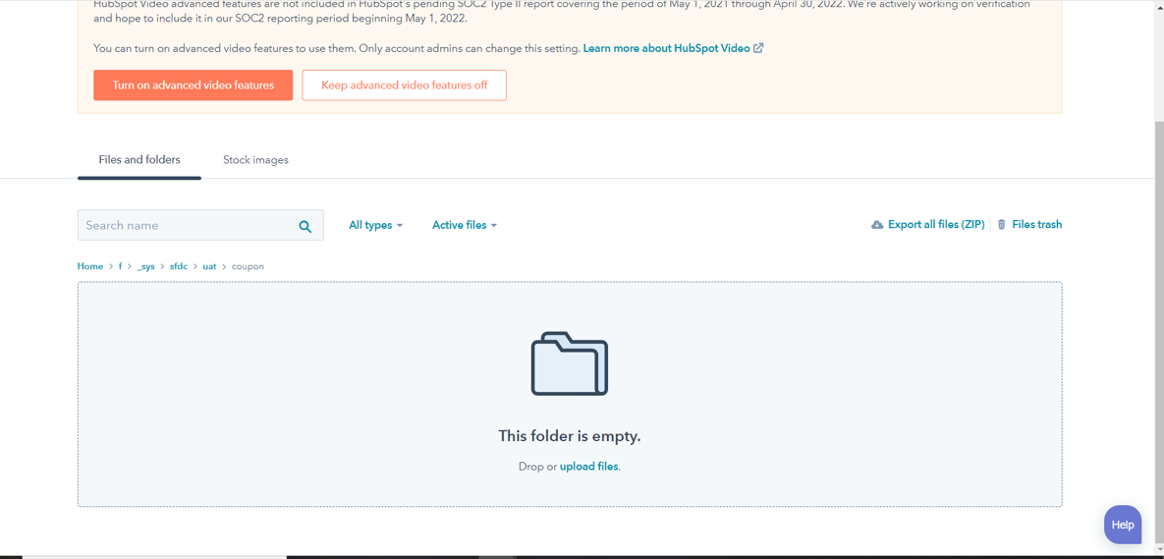

# TO GET ASSET URL

1. Click on Details

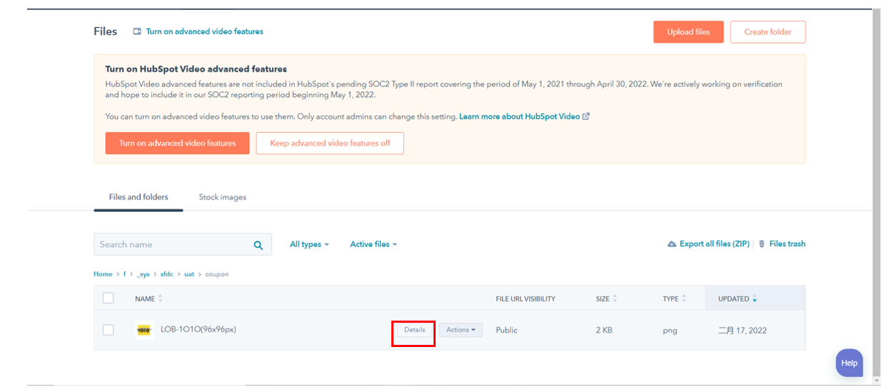

1. Click Copy URL for the image URL.

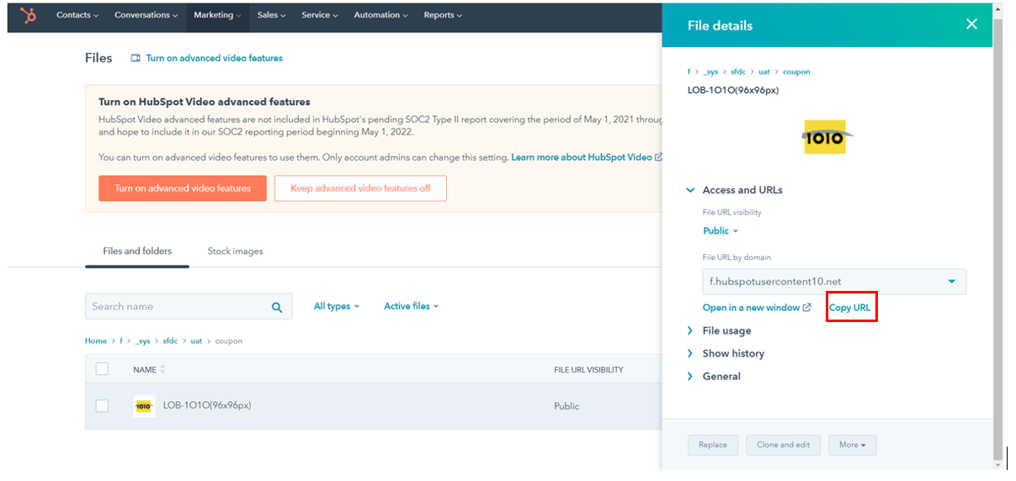

# TO REPLACE EXISTING ASSET

1. Find the existing image
2. Click on Details



1. Click “Replace”

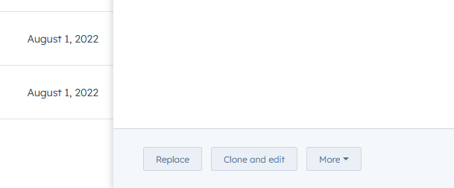

1. Upload the file

# TO DOWNLOAD ASSET

1. Find the existing asset
2. Click on Details
3. Click More
4. Click Download

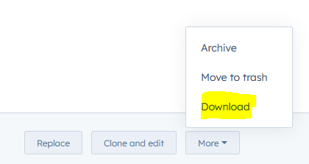

# TO DELETE ASSET

1. Find the existing asset
2. Click on Details
3. Click More
4. Click Archive

